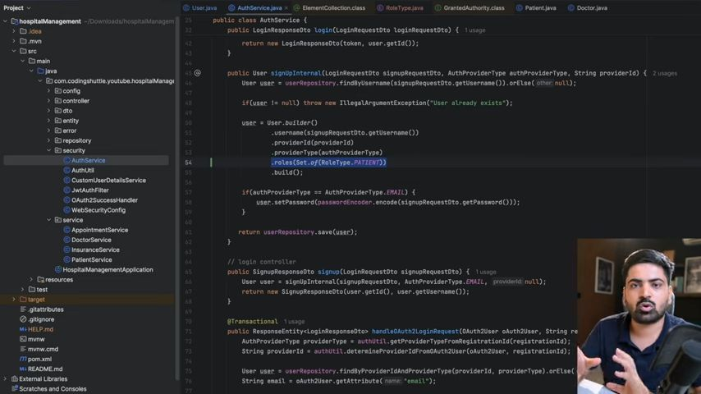Yaha pe humne ye kia hai ki jo bhi user signup krega usko ek role milgea PATIENT ka and baad mai 1 user ko multiple role bhi de skte hai hum

And agr same user ko multiple role dia toh iss table mai ek new row create ho jayegi with different role.
Hume user ko patient and doctor k sath bhi attatch krna hai because user can be a patient and doctor. So we have to do one-to-one mapping.
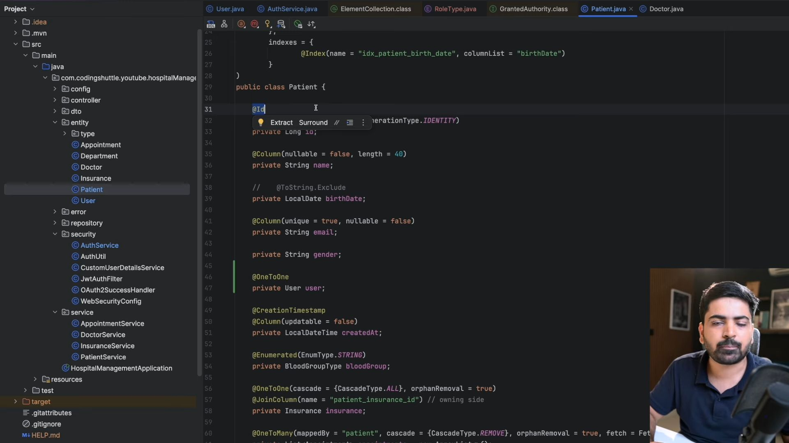Ab hamare patient k pass ek apni id hai and user k pass bhi apni ek id hai and user k pass username bhi hai toh system k pass bahut saari id's aa gyi hai same cheeze k liye so for that what we can do is we can define map id.
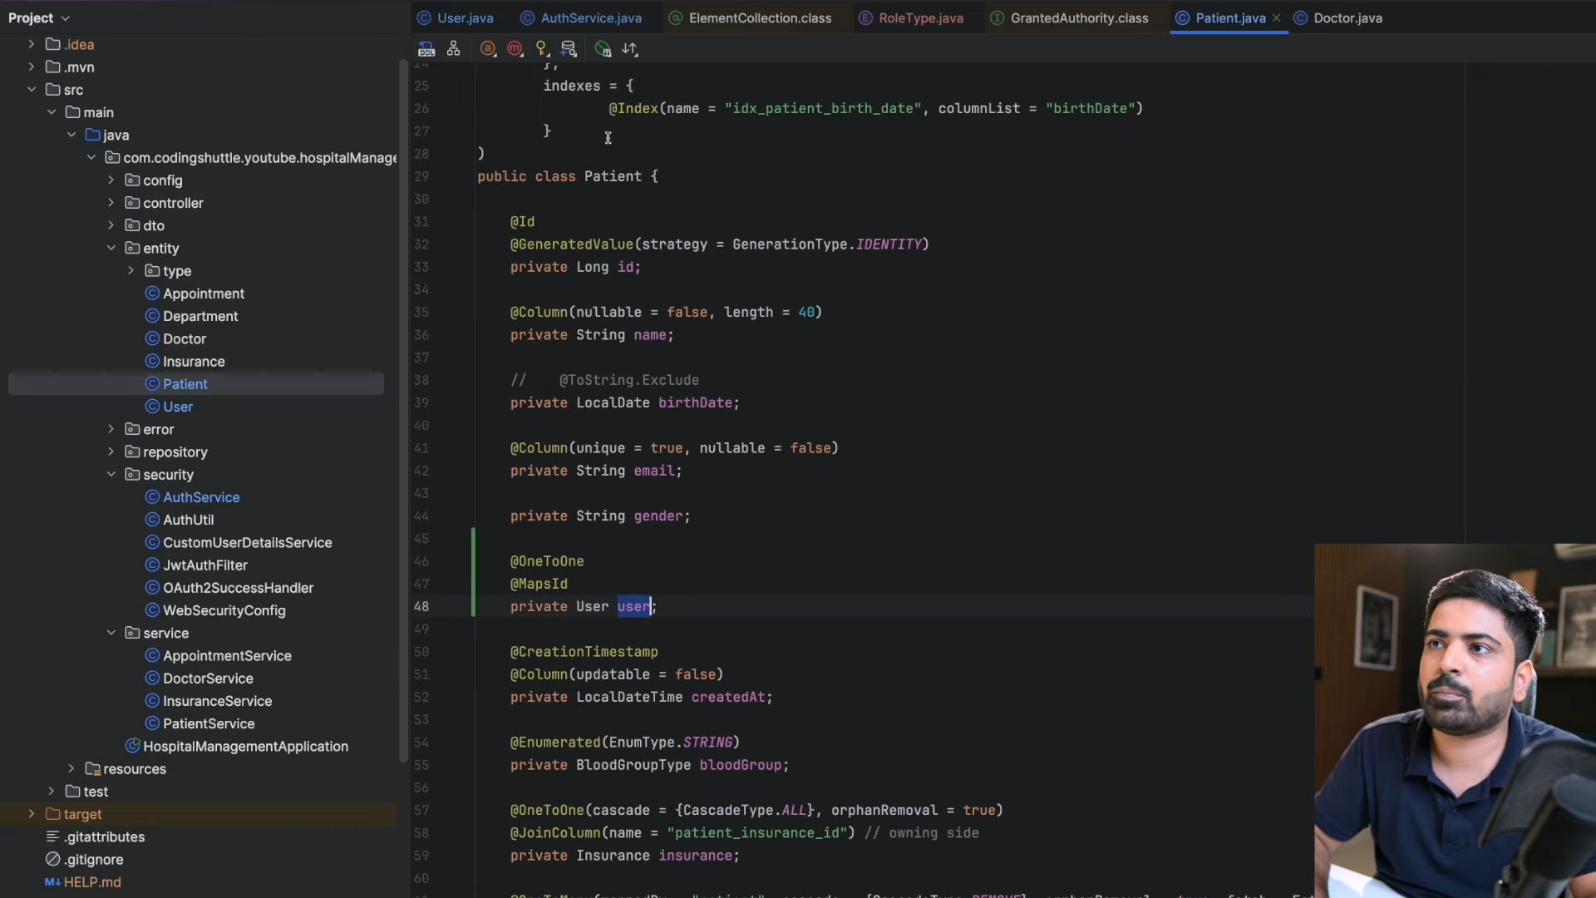Isse hoga ye ki ab patient k pass uski id nhi hogi db mai; uske pass bs userid hogi. Hibernate patient ki id ko user ki id k barabar he kr dega.
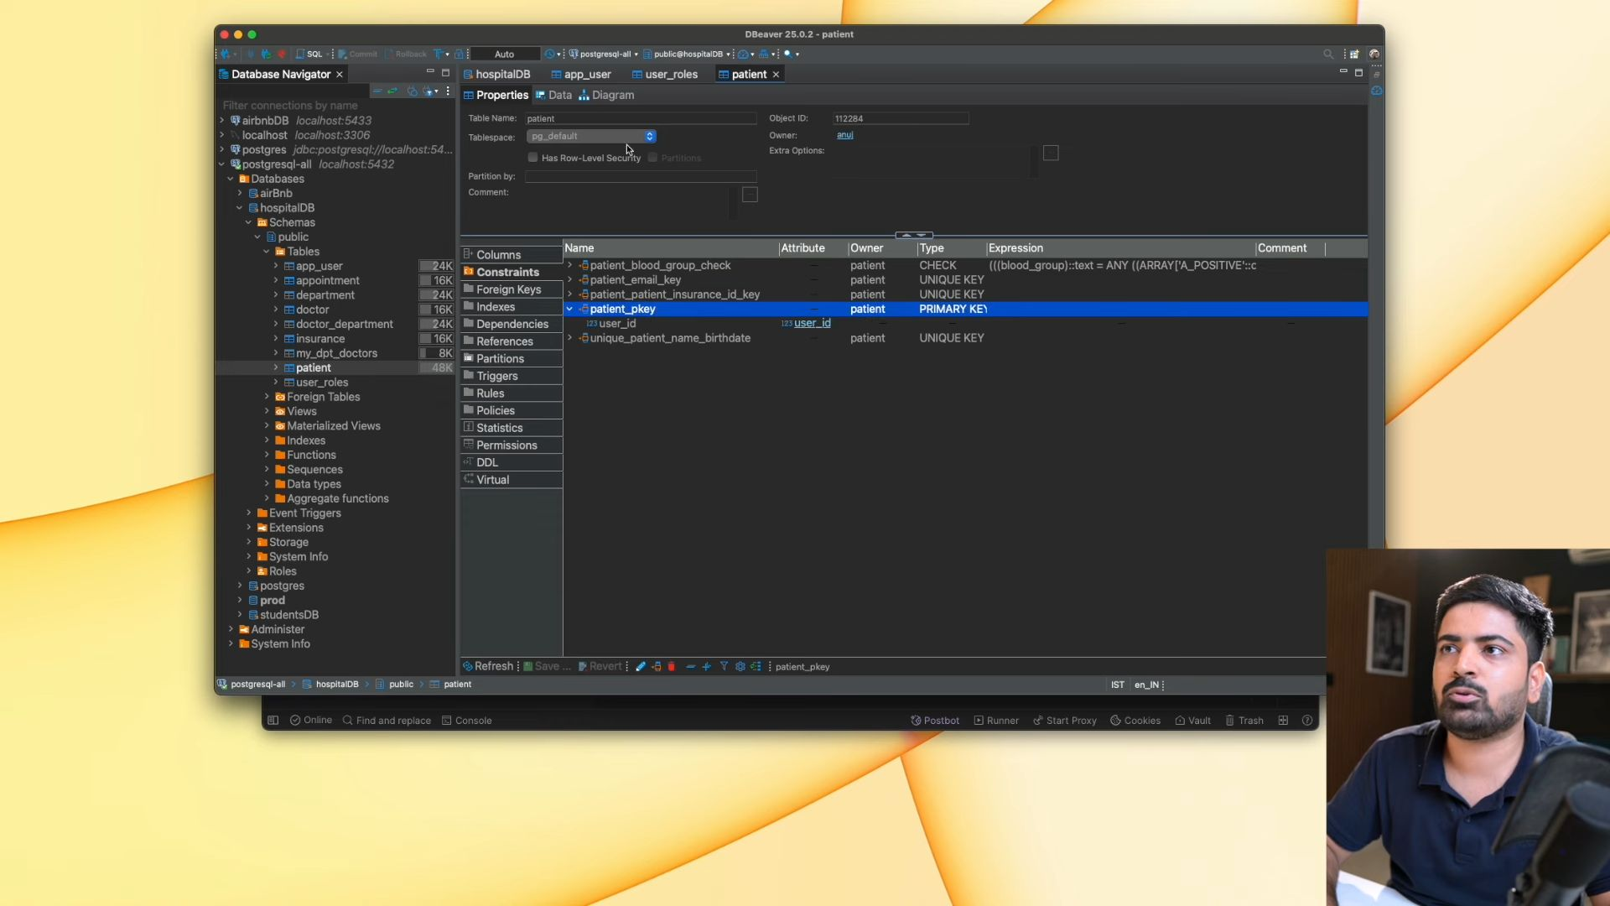Same thing we will do for Patient also.
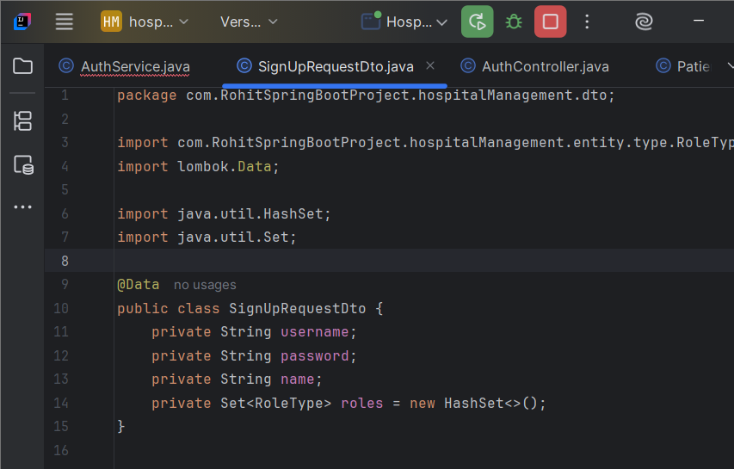We have defined signUpRequestDto also. Auth Controller mai signup krte time ab LoginReqDto na use krke hum ye signup wala use krnege and same uske ander k baaki methods mai.
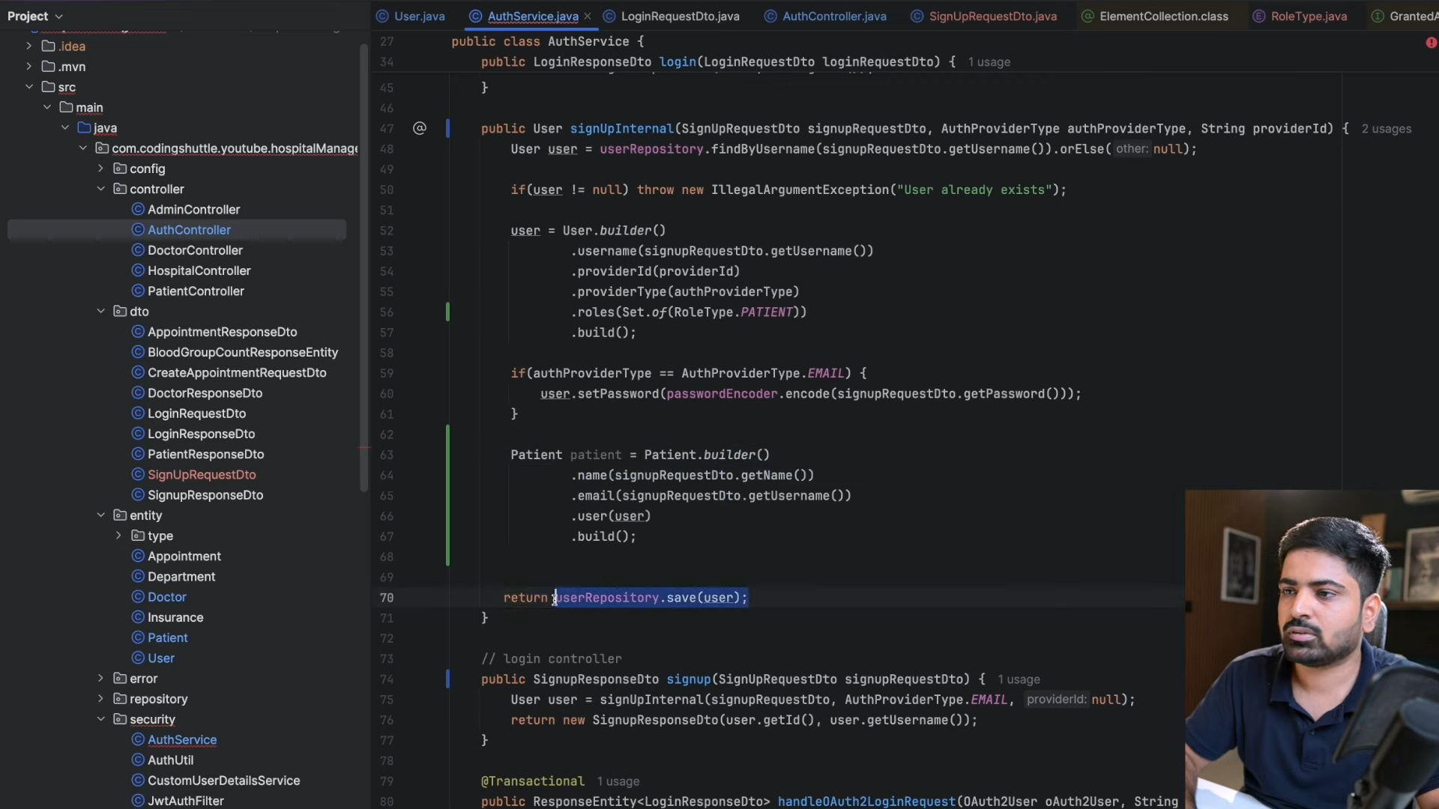
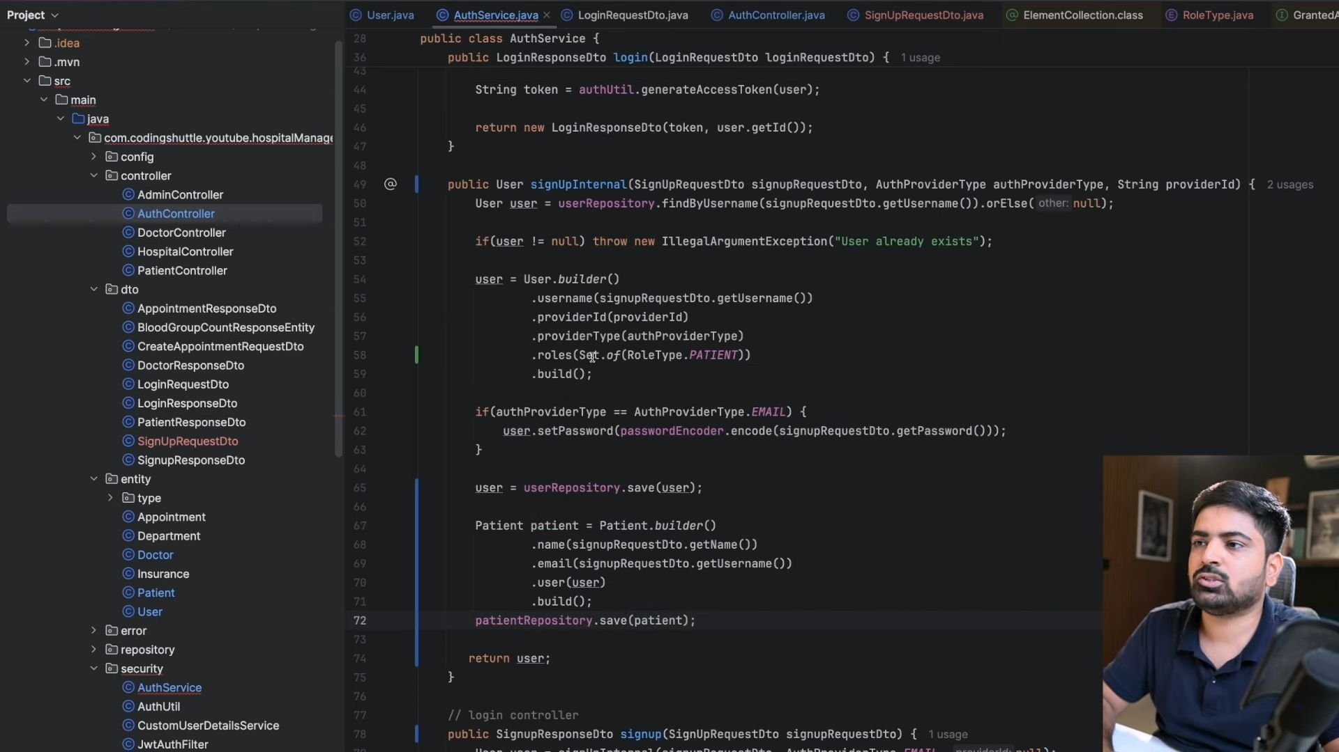
Now Granular Level access Control Permissions
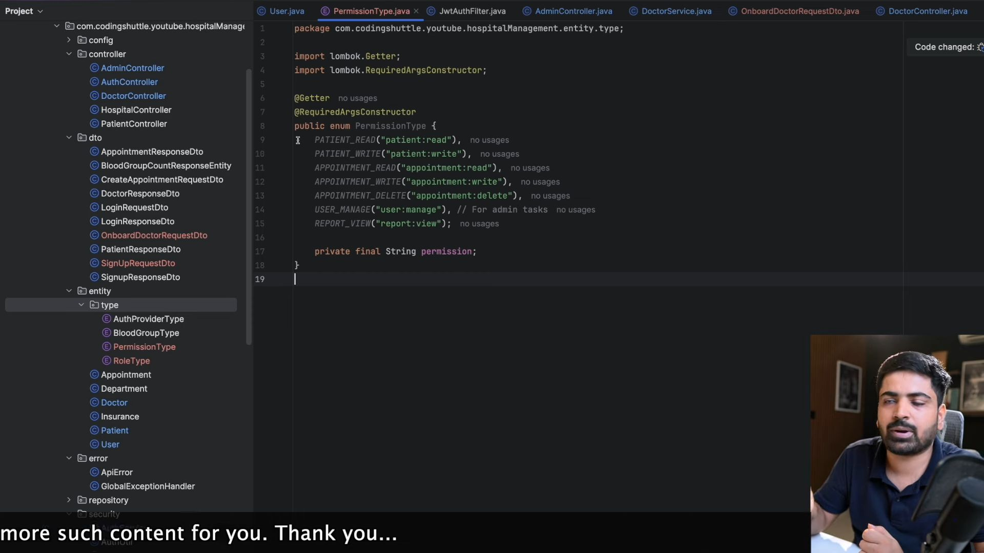
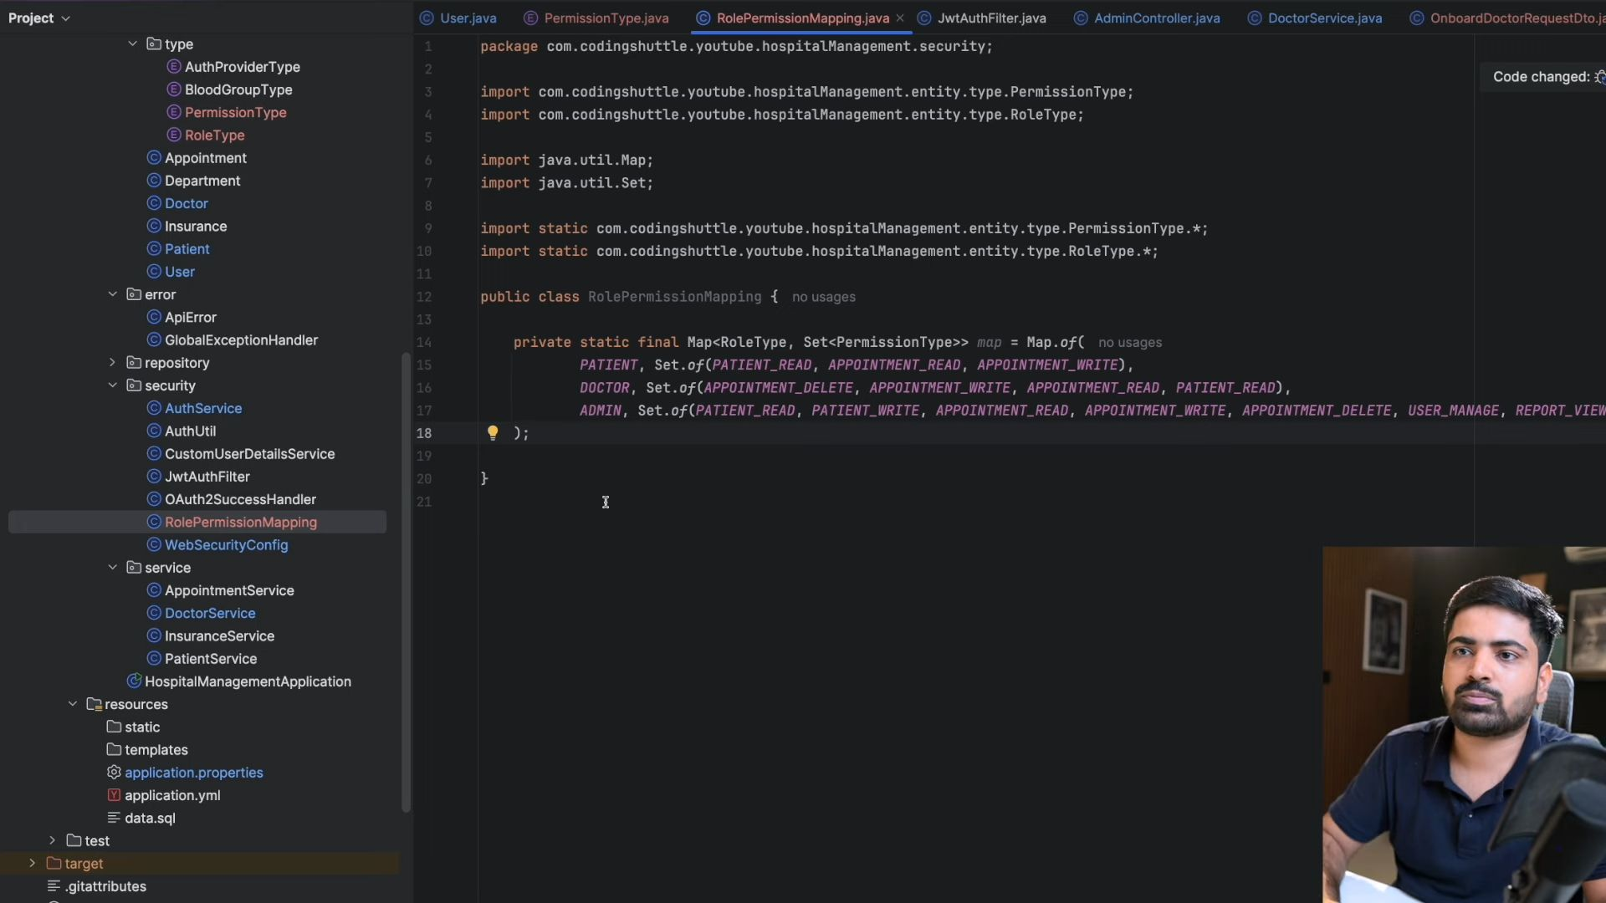
Abhi tak security lagare rhe api lvl pe requestmatcher krke hum isko Method level pe bhi lga skte hai.ki admin he sirf iss method ko call kr payega koi aur ni.
